### Easter Bunny Swing Card

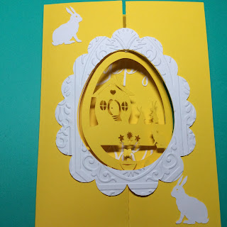

Easter Bunny Swing Card

I made this Easter card to look like the inside of an egg. The interior scene swings outward. I recommend adding a dot of glue at the top and bottom of this scene as this will tear if the card is repeatedly opened and closed. The card is sized for an A6 envelope.

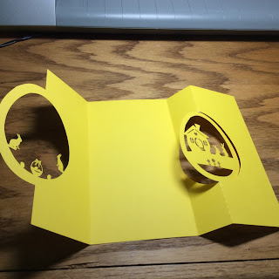

Fold the card as shown.

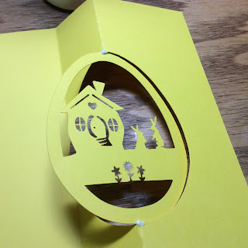

I added a dot of glue at the stress points.

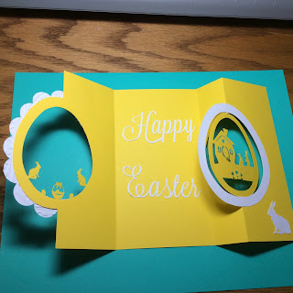

Add the embellishments.

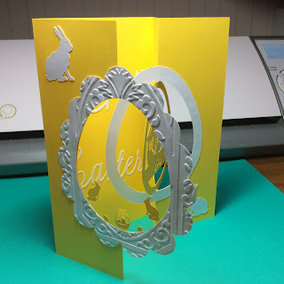

Happy Easter!!!